

Policy Title: Mental Health Policy

Policy Folder: Pastoral

Reviewed: September 2025

Next Review: September 2026

Led by: Senior Mental Health Lead/Mental Health & Wellbeing Governor

Responsible
Committee: FGB

Our School Intent
Our school values every member of the school community. We aim to provide an environment that nurtures Confidence, Achievement, Respect and Enthusiasm (C.A.R.E.) in all aspects of life. We all work together to provide a happy, safe and secure school in which we encourage all children to set their sights high, to make the most of their talents and to celebrate differences. We work hard to create challenging and fun learning opportunities that enable everyone to be confident and responsible members of the society in which we live. The staff and governors are committed to maintaining the strong and supportive partnership between pupils, parents, carers, teachers and the wider community.

Policy Statement
At Lantern Lane Primary School, we are committed to supporting the emotional health and wellbeing of our pupils and staff.

We have a supportive and caring ethos and our approach which is respectful and kind is relationship based, where each individual and their contribution is valued.

At our school we know that everyone experiences life challenges that can make us vulnerable and at times, anyone may need additional emotional support. We take the view that positive mental health is everybody’s business and that we all have a role to play. At our school we:

- help children to understand their emotions and feelings better
- help children feel comfortable sharing any concerns or worries
- help children socially to form and maintain relationships
- promote self-esteem and ensure children know that they count
- encourage children to be confident and ‘dare to be different’
- help children to develop emotional resilience and to manage setbacks

We promote a mentally healthy environment through:

- promoting our school values and encouraging a sense of belonging
- promoting pupil voice and opportunities to participate in decision-making
- celebrating academic and non-academic achievements
- providing opportunities to develop a sense of worth through taking responsibility for themselves and others
- providing opportunities to reflect
- access to appropriate support that meets their needs

We pursue our aims through:

- universal, whole school approaches
- support for pupils going through recent difficulties including bereavement
- specialised, targeted approaches aimed at pupils with more complex or long term difficulties including attachment disorder

Scope
This policy should be read in conjunction with our Medical and our SEND policy in cases where mental health needs overlap with these. This policy should also be read in conjunction with policies for Behaviour and Anti-bulling, and PSHE and SMSC policies. It should also sit alongside safeguarding procedures.

Lead Members of Staff
Whilst all staff have a responsibility to promote the mental health of students, staff with a specific, relevant remit include:

- Pete Fowlie - Head Teacher/ Designated Safeguarding Lead (DSL)
- Nuala Thompson - Mental Health lead/ SENCO/ Deputy DSL
- Paula Panther - Assistant Head/ Deputy DSL
- Jen Evans - Wellbeing Support Assistant/Deputy DSL
- Kellie Tate - Emotional Literacy Support Assistant (ELSA)
- Nicholas McGowan – Governor with responsibility for wellbeing
Staff Wellbeing
At Lantern Lane we recognise that anyone can experience mental health issues for various reasons which may be out of their control. There may also be work related factors that could contribute to poor mental health such as work life imbalance, work load pressure or poor working conditions. To every extent possible, we aim to recognise and address cases of work place pressures that contribute to mental health issues.
At our school there is a mentally healthy environment where staff:

- have their individual needs recognised and responded to in a holistic way
- have a range of systems in place to support mental wellbeing e.g. appraisal, briefings, training
- have recognition of their work-life balance
- feel valued and have opportunities in the decision-making process
- success is recognised and celebrated
- are provided with opportunities for CPD both personally and professionally
- can access support and guidance at times of emotional need in both the short and long term, (including counselling and Occupational Health).
- will have flexible working requests considered.

Mental Health and Emotional Wellbeing Support
The school will offer support through universal, targeted and individual approaches for pupils or groups of pupils which may include:

Universal | Targeted | Individual
- Positive relationships between staff and children (based on an emotion coaching model).  - Objectives taught to the whole class as part of the PSHE curriculum.  - Assembly programme  - Managing feelings resources e.g. check in boards, worry boxes etc  - Active classrooms e.g. sensory breaks, Go Noodle etc  - Wellbeing initiatives e.g. House events, Feel Good Friday, Children’s mental health week etc.  - School council  - Pupil voice  - Well-being ambassadors | - Group ELSA sessions based on specific needs e.g. friendships, anxiety  - Well-being support assistant groups e.g. friendship groups, garden club, lunchtime provision etc  - Circle of friends activities.  - Social stories  - Anger management groups | - 1:1 ELSA sessions  - 1:1 Well-being support assistant sessions (including regular check-ins)  - Lego therapy  - Bespoke sensory diets for specific children  - Social stories specifically designed for the pupil.  - Access support from external agencies e.g Healthy Families, CAMHS, Early Help unit

The school will make use of resources to assess and track wellbeing as appropriate including:

- Strengths and Difficulties questionnaire
- The Boxall Profile
- Emotional literacy scales
- Sensory audits
- Attendance tracking
- SLT reviews

Signposting
We will ensure that staff, pupils and parents are aware of what support is available within our school and how to access further support. The Senior Mental Health Lead will support staff to access support from external services and will alert staff to current initiatives and new avenues of support.

Identifying Risk and Protective Factors
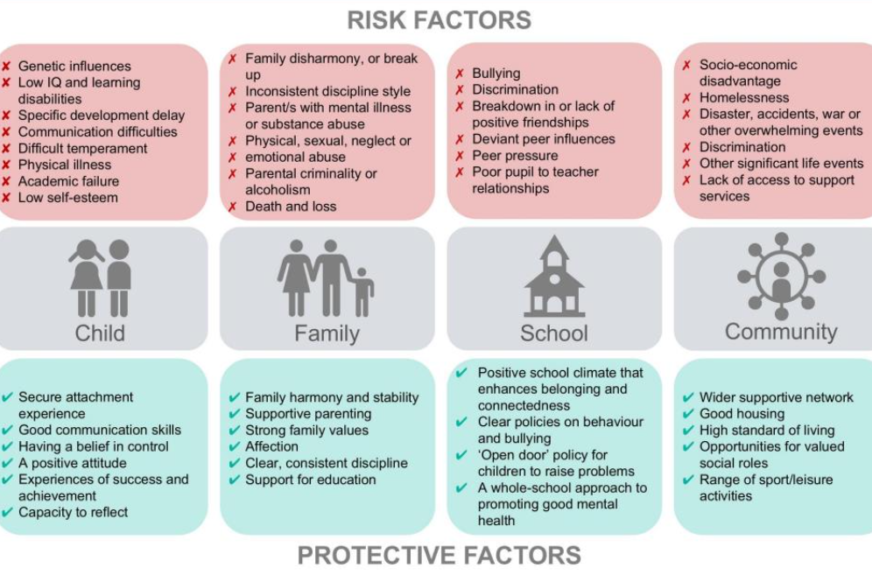
These factors can relate to the child but also to their family, school and community as referenced in the table below.

Staff training around mental health includes these risks and protective factors. When looking at these, staff will consider factors such as:

- Attendance
- Health needs
- Special Educational Needs and Disability
- Safeguarding concerns
- The impact of COVID-19

School staff are also aware of warning signs which indicate a student is experiencing mental health or emotional wellbeing issues. These warning signs should always be taken seriously and staff observing any of these warning signs should communicate their concerns with the designated safeguarding lead or senior mental health lead.

Working with Parents
In order to support parents, we will:

- Highlight sources of information and support about mental health and emotional wellbeing on our school website.
- Ensure that all parents are aware of who to talk to if they have concerns about their child.
- Make our emotional wellbeing and mental health policy easily accessible to parents.
- Share ideas about how parents can support positive mental health in their children.
- Work together with parents and external agencies for specific children in need to further targeted support.

We expect parents to:

- inform us of circumstances that may affect the mental health of either the child or themselves.
- to engage fully with any support offered to them or their child.

Working with external agencies
As part of our provision the school will work with other agencies to support children’s emotional health and wellbeing including:

- Educational Psychologists
- ELSA support
- CAMHS
- Primary Mental Health team
- Rushcliffe Primary SEMH Partnership
- Early help unit
- Healthy Families Team
- SEND Inclusion Service
- Social Care

Further details (including how to contact these agencies) can be found on our website.

Training
All staff will receive regular training about recognising and responding to mental health issues as part of their regular safeguarding in order to enable them to keep students safe.

The Educare learning portal provides free online training suitable for staff wishing to know more about a specific issue.

Training opportunities for staff who require more in-depth knowledge will be given when needed around specific groups or individual pupils.

Mental Health Links
Further links are available on our website
- https://www.place2be.org.uk/
- https://nottalone.org.uk/?a=pc
- https://www.nhs.uk/oneyou/every-mind-matters/
- https://www.annafreud.org/
- https://www.elsa-support.co.uk/
- https://www.minded.org.uk/
- https://www.time-to-change.org.uk/
- https://www.turning-point.co.uk/

