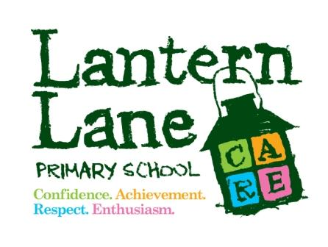

Policy Title: Parent/Carer Code of Conduct

Policy Folder: Pastoral

Created: April 2018

Reviewed: Feb-25

Next Review: Feb-28

Led By: Headteacher

Responsible Committee: SD Committee

CODE OF CONDUCT FOR PARENTS, CARERS & VISITORS

1. Purpose and scope

At Lantern Lane, we believe it’s important to:

- Work in partnership with parents to support their child’s learning
- Create a safe, respectful and inclusive environment for pupils, staff and parents
- Model appropriate behaviour for our pupils at all times

To help us do this, we set clear expectations and guidelines on behaviour for all members of our community. This includes staff (through the staff code of conduct) and pupils (through our behaviour policy).
This code of conduct aims to help the school work together with parents by setting guidelines on appropriate behaviour.

We use the term ‘parents’ to refer to:

- Anyone with parental responsibility for a pupil
- Anyone caring for a child (such as grandparents or child-minders)

2. Our expectations of parents and carers

We expect parents, carers and other visitors to:

- Respect the ethos, vision and values of our school
- Work together with staff in the best interests of our pupils
- Treat all members of the school community with respect – setting a good example with speech and behaviour
- Seek a peaceful solution to all issues
- Correct their own child’s behaviour (or those in their care), particularly in public, where it could lead to conflict, aggression or unsafe conduct
- Approach the right member of school staff to help resolve any issues of concern

3. Behaviour that will not be tolerated

- Disrupting, or threatening to disrupt, school operations (including events on the school grounds and sports team matches)
- Swearing, or using offensive language
- Displaying a temper, or shouting at members of staff, pupils or other parents
- Threatening another member of the school community
- Sending abusive messages to another member of the school community, including via text, email or social media
- Posting defamatory, offensive or derogatory comments about the school, its staff or any member of its community, on social media platforms
- Use of physical punishment against your child while on school premises
- Any aggressive behaviour (including verbally or in writing) towards another child or adult
- Disciplining another person’s child – please bring any behaviour incidents to a member of staff’s attention
- Smoking, vaping or drinking alcohol on the school premises (unless alcohol has been allowed at a specific event)
- Possessing or taking drugs (including legal highs)
- Bringing dogs onto the school premises (other than guide dogs)

4. Breaching the code of conduct

If the school suspects, or becomes aware, that a parent has breached the code of conduct, the school will gather information from those involved and speak to the parent about the incident. Depending on the nature of the incident, the school may then:

- Send a warning letter to the parent
- Invite the parent into school to meet with a senior member of staff or the headteacher
- Contact the appropriate authorities (in cases of criminal behaviour)
- Seek advice from [the local authority’s legal department regarding further action (in cases of conduct that may be libellous or slanderous)
- Ban the parent from the school site

The school will always respond to an incident in a proportional way. The final decision for how to respond to breaches of the code of conduct rests with the headteacher. The headteacher will consult the chair of governors before banning a parent from the school site.

If a bar from the School premises is necessary, we comply with the Department for Education (DfE) ‘Controlling access to school premises guidance’, which states the following:

Barring individuals from school premises

Trespassing is a civil offence. This means that schools can ask someone to leave and take civil action in the courts if someone trespasses regularly. The school may want to write to regular trespassers to tell them that they are potentially committing an offence. Schools can bar someone from the premises if they feel that their aggressive, abusive or insulting behaviour or language is a risk to staff or pupils. It’s enough for a member of staff or a pupil to feel threatened.

The school should tell an individual that they’ve been barred or they intend to bar them, in writing. Letters should usually be signed by the headteacher, though in some cases the local authority, academy trust or proprietor may wish to write instead. The individual must be allowed to present their side.

A school can either:

- Bar them temporarily, until the individual has had the opportunity to formally present their side;
- Tell them they intend to bar them and invite them to present their side by a set deadline. After the individual’s side has been heard, the school can decide whether to continue with barring them.

The decision should be reviewed within a reasonable time, decided by the school.

The Department for Education (DfE) does not get involved in individual cases.

